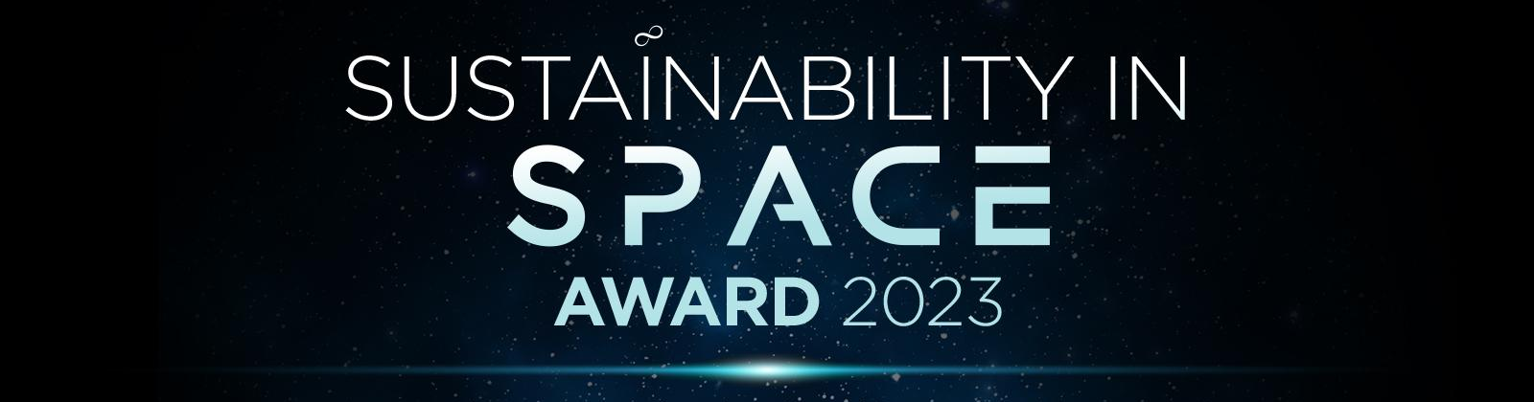
The ‘Sustainability in Space Award' celebrates projects and organisations which are making a direct contribution to the sustainability of space. Awarded on an annual basis and open to companies and projects from EU/ESA Member States, the award seeks to recognise the contribution and impact that an organisation or project is having on boosting the sustainability of the space ecosystem by tackling challenges such as space debris and overcrowding.
The winner of the award will be selected by a panel of expert judges consisting of representatives from the European Commission, ESA and leading space and satellite trade associations, with participants at The European Space Forum also getting a say through an audience vote. Nominees will be judged on the impact that their project/service has on contributing to sustainable development in space, but also on the unique and innovative nature of the solution they provide. Consideration will also be given to long term viability, and the potential that solutions have to meet in delivering a safer, more sustainable space environment for future generations.
Nominations are now open! For more information or to nominate a specific organisation or project, please download the nomination form here. The deadline for nomination is Wednesday 31 May.
To nominate an organization or project for the Sustainability in Space Award, please complete the nomination form on the next page. Save the file and email it to space@forum-europe.com.
The deadline for submissions is 31 May.
All shortlisted organisations or projects will be selected and notified by 16 June and will have the opportunity to provide a short video presentation to showcase their specific innovations and explain why they deserve the title of Europe’s most sustainable space actor of 2023.
The winner will be announced during the conference, taking place on 5-6 July 2023.
If you have any questions or require any more information regarding the awards or nomination process, please email space@forum-europe.com or call +44 (0) 2920 783 070.

THE SUSTAINABILITY IN SPACE AWARD 2023
NOMINATION FORM – Submission Deadline: 31 May

When filling out the form, please clearly describe your product or service. Answer all the questions in an understandable manner as possible. Would anyone outside of your industry be able to understand your work?

NOMINEE CONTACT INFORMATION

Contact Person:
Job title:
Organisation:
Telephone:
Email:

SUSTAINABILITY IN SPACE AWARD – SUBMISSION FORM

Name of project nominated:

Name of company:

In which EU / ESA Member State is your organisation based?

Describe how the project/product/service nominated is contributing to sustainability of space? What unique and new solutions does the project/product/service offer that makes them stand out from others?

What results and achievements have been seen so far (in either real-life or test environments)?

How is the company communicating the story of their project/product/service and the sustainable benefits that it provides?

Describe the overall goals and objectives of the project/product/service and how it aims to foster sustainable development in the space secto. What are their longer-term plans, and what potential does it have to help deliver a safer and more sustainable environment for future generations?

Please provide any additional information to support your nomination:

